# Cvičenie 09- Hrašna, Suroviak

# **Experimenty MLP s LFI**

Našou počiatočnou úlohou bolo podľa schémy zapojiť 2 routre a k nim pripojené 2 počítače podľa zadania. Podľa zadania sme ich aj nakonfigurovali a to konkrétne statické ip (statické smerovanie) pre routre aj PC, clock rate 128000, bandith 128.

**R1**

**R2**

**10.0.1.0 / 24**

**10.0.2.0 / 24**

**10.0.12.0 / 24**

**128 k**

**clock rate**

**bandwidth**

**Sender**

**Reciever, WS**

**S0**

**S0**

**f0**

**f0**

V D-ITG sme nastavili 2 toky:

Voice – G.711 – 2 sample na packet

Exponenciálny UDP tok s veľkosťou 700B a intenzitou 6p/s

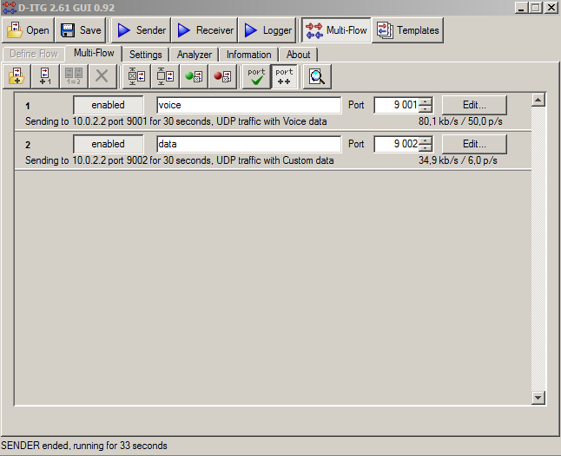

**Úloha 1:** Meranie **oneskorenia** a **jitter** na pomalej sériovej linke pre VoIP tok s využitím multilink PPP a LFI

Scenár: **1 linka**, b**ez použitia LFI aj bez prioritizácie pre VoIP pakety**, iba encapsulation ppp:

* Čierna = hlas
* Čerená = dáta

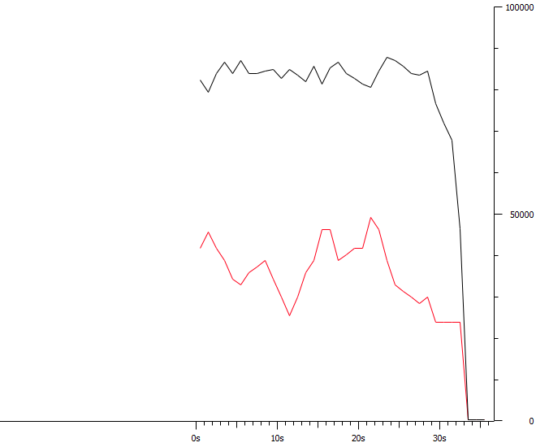

__________________________________________________________

**************** TOTAL RESULTS ******************

__________________________________________________________

Number of flows = 2

Total time = 30.468000 s

Total packets = 1688

Minimum delay = -50.199000 s

Maximum delay = -49.542000 s

Average delay = -49.891535 s

Average jitter = 0.012159 s

Delay standard deviation = 0.168567 s

Bytes received = 389600

Average bitrate = 102.297492 Kbit/s

Average packet rate = 55.402389 pkt/s

Packets dropped = 0 (0.00 %)

Average loss-burst size = 0 pkt

Error lines = 0

Poznámka: výstupy z excelu máme z iných routrov ako screenshoty z wiresharku – preto hodnoty nesuhlasia ( mali sme problemy s routrom )

Priemerný jitter z v exceli:0,023697

Scenár2: **1 linka**, b**ez použitia LFI ale už s prioritizáciou pre VoIP pakety** (policy map – priority 90 [kbps])

Konfigurácia:

access-list 101 permit udp any any eq 9001

class-map match-all ZAKAZNIK  
 match access-group 101

policy-map PRIORITApreHLAS  
 class ZAKAZNIK  
  bandwidth 90

interface Multilink1

ip address 10.0.12.1 255.255.255.0

ppp multilink

ppp multilink group 1

interface Multilink1  
 service-policy output PRIORITApreHLAS

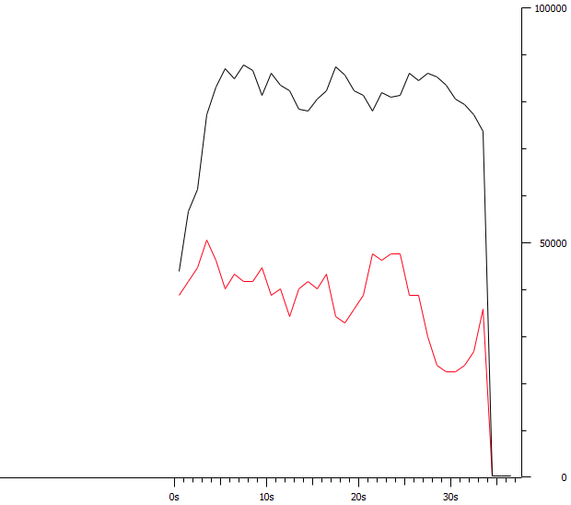

**************** TOTAL RESULTS ******************

__________________________________________________________

Number of flows = 2

Total time = 31.175000 s

Total packets = 1707

Minimum delay = 3.276000 s

Maximum delay = 4.531000 s

Average delay = 3.969931 s

Average jitter = 0.013887 s

Delay standard deviation = 0.313682 s

Bytes received = 402900

Average bitrate = 103.390537 Kbit/s

Average packet rate = 54.755413 pkt/s

Packets dropped = 0 (0.00 %)

Average loss-burst size = 0 pkt

Error lines = 0

Priemerný jitter z v exceli: 0,008281

Scenár3: **1 linka**, s **použitím LFI a prioritizáciou pre VoIP pakety**

**Konfigurácia:**

interface Multilink1  
 ip address 10.0.12.1 255.255.255.0  
 ppp multilink  
 ppp multilink interleave  
 ppp multilink group 1  
 ppp multilink fragment size 200

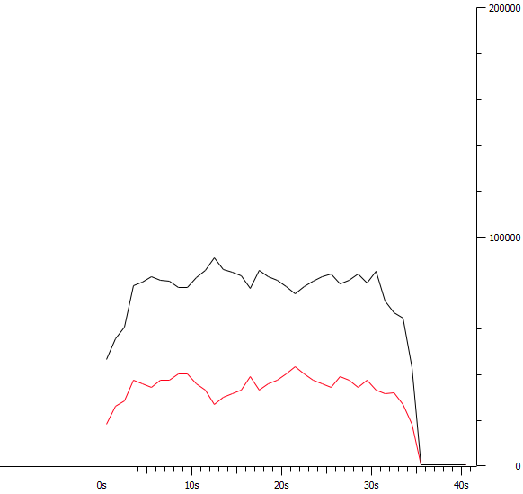

**************** TOTAL RESULTS ******************

__________________________________________________________

Number of flows = 2

Total time = 31.580000 s

Total packets = 1691

Minimum delay = -1.185000 s

Maximum delay = 0.464000 s

Average delay = -0.352338 s

Average jitter = 0.014911 s

Delay standard deviation = 0.463749 s

Bytes received = 391700

Average bitrate = 99.227359 Kbit/s

Average packet rate = 53.546548 pkt/s

Packets dropped = 0 (0.00 %)

Average loss-burst size = 0 pkt

Error lines = 0

Priemerný jitter v exceli:0,008472

Scenár4 : 2 linky, s použitím LFI a prioritizáciou pre VoIP pakety

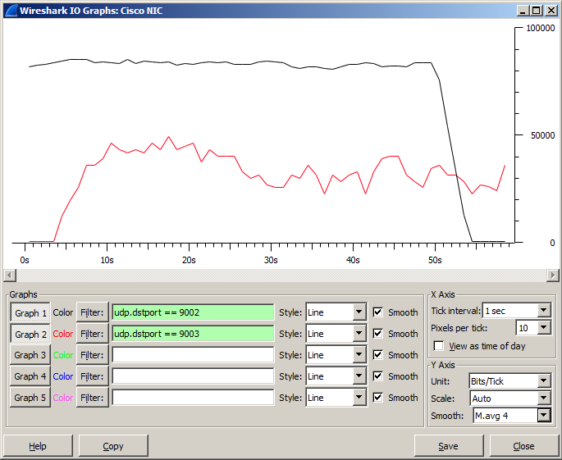

Poznámka: Graf je od dvojice Andrej Kováč, Samuel Kurnas, pretože náš screenshot mal z nejakého dôvodu 0kb.

__________________________________________________________

**************** TOTAL RESULTS ******************

__________________________________________________________

Number of flows = 2

Total time = 28.997000 s

Total packets = 1680

Minimum delay = -38.819000 s

Maximum delay = -37.782000 s

Average delay = -38.308464 s

Average jitter = 0.008593 s

Delay standard deviation = 0.316488 s

Bytes received = 384000

Average bitrate = 105.941994 Kbit/s

Average packet rate = 57.937028 pkt/s

Packets dropped = 0 (0.00 %)

Average loss-burst size = 0 pkt

Error lines = 0

Priemerný jitter v exceli: 0,004508

Úloha 2: Meranie času, za ktorý sa prenesie 1 MB súbor cez 1, 2 alebo 3 linky s využitím multilink PPP.

1 Sériová linka – multilink – posielali sme 1 súbor o veľkosti 1,3Mb a bol poslaný za 159 sekúnd, čo vychádza na 101 kbit/s

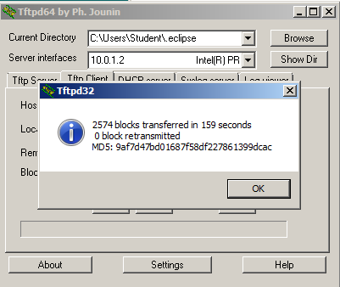

2 sériové linky – multilink – posielali sme 1 súbor o veľkosti 1,3Mb a bol poslaný za 108 sekúnd, čo vychádza na 176 kbit/s

